**Joint Observing System Simulation Experiment (JOSSE) Data set**

**at NASA/NCCS portal and NCAR**

as of January 2012

The data set described in this manuscript contains the data required to conduct initial OSSEs. The data set includes existing observations from the 2005-2006 Nature Run period and these data are considered as control observations to study the impact of additional observations. These data are also useful for OSSE to evaluate data assimilation systems. A Nature Run on a low resolution regular grid for OSSE verification is also included.

The data set consists of (A) ECMWF Nature Run at low resolution pressure levels to verify OSSE experiments, (B) simulated and real observations for control experiments, and (C) cloud data for cloud evaluation.

The complete Nature Run at model resolution and additional data are posted on the NASA/NCCS portal. It is easier to view the data at NASA as the NCAR data are saved on tape, but it is easier to download large quantities of data from NCAR.

Data set names at NCAR are marked in green. Currently the data are saved in the HPSS archive. Individual files are viewable from the NASA/NCCS/portal. The URL locations at the NASA portal are indicated in purple.

**Contact about details of the data set**

Michiko Masutani

NOAA/NWS/NCEP/EMC

michiko.masutani@noaa.gov

Office: (301)763-8000x7551

Progress and update will be posted from

<http://www.emc.ncep.noaa.gov/research/JointOSSEs/data>

**[NCAR data set]**

**Currently saved in HPSS**

**Data ID: ds621.0**

[**http://dss.ucar.edu/datasets/ds621.0/matrix.html**](http://dss.ucar.edu/datasets/ds621.0/matrix.html)

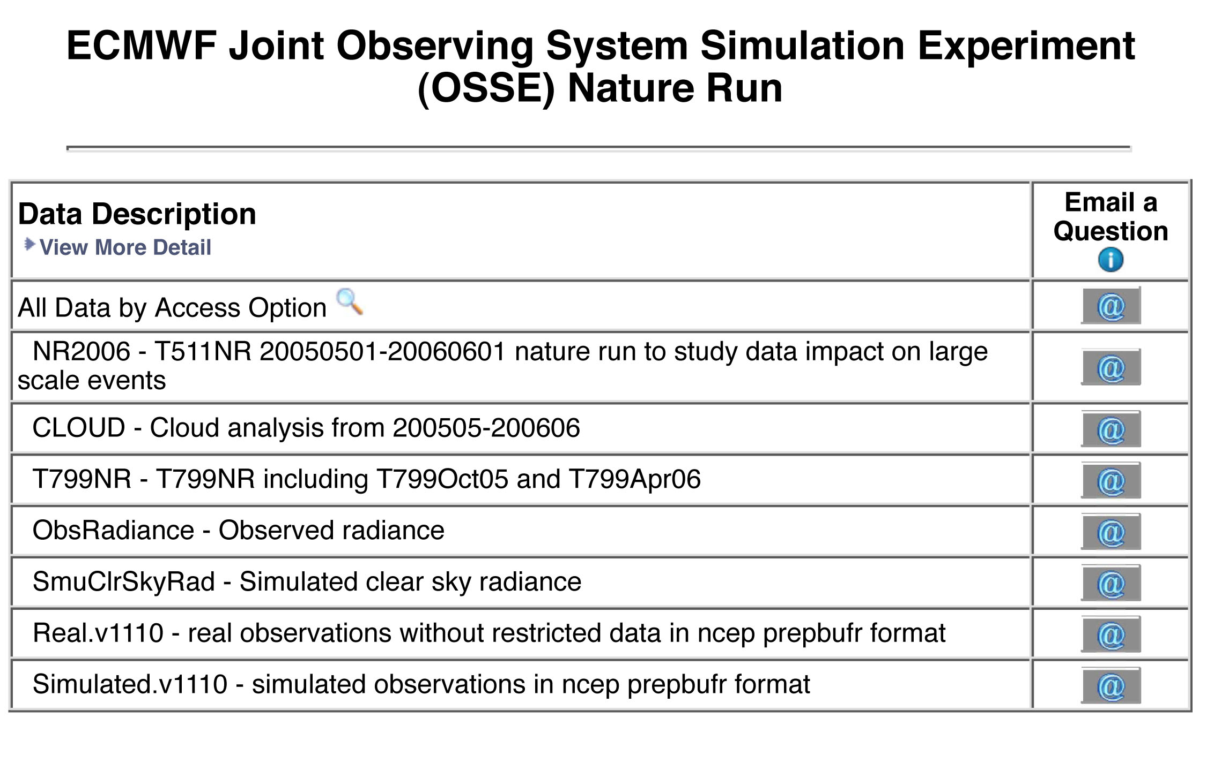

**NCAR Contact:**

**Chi-Fan Shih** [**chifan@ucar.edu**](mailto:chifan@ucar.edu)

**Steven Worley** [**worley@ucar.edu**](mailto:worley@ucar.edu)

**[NASA/NCCS portal]**

[**https://portal.nccs.nasa.gov/osse/index.pl**](https://portal.nccs.nasa.gov/osse/index.pl)

**(User ID and Password required)**

**Nature run data provided by EMCWF**

[**http://portal.nccs.nasa.gov/josse/index.pl**](http://portal.nccs.nasa.gov/josse/index.pl)

**Processed data including simulated observations**

**NASA/NCCS Contact**

**Ellen Salmon [Ellen.M.Salmon@NASA.gov](mailto:Ellen.M.Salmon@NASA.gov)**

**A. ECMWF Nature Run at low resolution pressure levels to verify OSSE experiments.**

**NCAR Dataset name: NR2006 and T799NR**

**NASA Portal: https://portal.nccs.nasa.gov/osse/**

**[Summary]**

A broad group of US and international partners organized and agreed to have ECMWF compute a high resolution global gridded dataset that serves as a reference data set for general and collaborative observing system simulation experiments (OSSE). This model output is termed a “Nature Run”, because it is intended to be the best representation possible of the true environmental conditions. The temporal and spatial resolutions are sufficient so the data may be used as an experimental sample and validation data for planning future observing systems. It is especially valuable for assessing future satellite systems.

Summary of the background of Joint OSSEs is posted at http://www.emc.ncep.noaa.gov/research/JointOSSEs/data/ECMWF_Joint_OSSE_NR.BackGround.html

Description of the complete data is posted at

http://www.emc.ncep.noaa.gov/research/JointOSSEs/data/ECMWF_Joint_OSSE_NR.Data_Description.html

**[Usage and credit]**

This data must not be used for commercial purposes. ECMWF and Joint OSSEs must be given credit in any publications in which this data is used. A user list will be tracked at NCAR and shared with ECMWF and Joint OSSE. Re-distribution rights have not been given.

If you are interested in using the data set, please send the following note by E-mail with your name and affiliation to Michiko Masutani at michiko.masutani@noaa.gov. Your name will be added to the user list and sent to ECMWF.

"I agree not to copy the ECMWF data or software provided by NCAR for use by other persons, and I agree not to use these data and/or software for commercial purposes. ECMWF will be given credit in any publications in which these data and/or software are used. I understand that if other persons in my organization wish to use these data and/or software, they must also sign a copy of this agreement."

**[Data distribution]**

The complete data for the T511NR, T799NR are saved at ECMWF, NCEP, NASA/NCCS, and ESRL. Model level data and surface data are saved as a reduced gaussian grid. Regular lat-lon gridded data for pressure levels, isentropic levels and surface data are also provided for verification purposes.

Access to the complete data are available through the NASA/GSFC/NCCS portal system.

http://portal.nccs.nasa.gov/osse/index.pl

Requires a user name and password.

**Selected data are posted from NCAR as data ID=ds621.0**

**http://dss.ucar.edu/datasets/ds621.0/matrix.html**

**A.1 T511 Nature Run interpolated to 1degx 1deg grid at NCAR**

**NCAR : NR2006**

**NASA Portal: https://portal.nccs.nasa.gov/osse/T511NR_1x1_date/**

**Format: Grib 1**

**Type: regular lat lon grid**

**Update: as required**

**Frequency: 3 hourly**

**Coverage: global**

**[Data description in each directory]**

**/NR2006/**

**pl.date.links.tar**

**pt.date.links.tar**

Expanding these tar balls generates the directories pl.date.links and pt.date.links and links for pl.date and pt.date.

**/NR2006/pl.tm**

Verification data are provided for 1deg x 1deg for T511 NR

Time series in pressure level

Pressure data in 1degx1deg   
Time series at 1000 925 850 700 600 500 400 300 250 50 10

Dprs 155 Divergence [s**-1]

Tprs 130 Temperature [K]

Uprs 131 U velocity [m s**-1]

Vprs 132 V velocity [m s**-1]

VOprs 138 Vorticity (relative) [s**-1]

Zprs 129 Geopotential [m**2 s**-2]

Wprs 135 Vertical velocity [Pa s**-1]

Qprs 133 Specific humidity [kg kg**-1]

**/NR2006/pl.date**

Verification data are provided for 1deg x 1deg for T511 NR

Pressure data at each time period

31 Pressure levels

1000 975 950 925 900 850 800 775 750 700 650 600 550 500 450 400 350 300 250 200 150 100 70 50 30 20 10 7 5 3 2 1

Variables  
CCprs 248 Cloud cover [(0 - 1)]

CIWCprs 247 Cloud ice water content [kg kg**-1]

CLWCprs 246 Cloud liquid water content [kg kg**-1]

Dprs 155 Divergence [s**-1]

O3prs 203 Ozone mass mixing ratio [kg kg**-1]

Qprs 133 Specific humidity [kg kg**-1]

Rprs 157 Relative humidity [%]

Tprs 130 Temperature [K]

Uprs 131 U velocity [m s**-1]

Vprs 132 V velocity [m s**-1]

VOprs 138 Vorticity (relative) [s**-1]

Wprs 135 Vertical velocity [Pa s**-1]

Zprs 129 Geopotential [m**2 s**-2]

**/NR2006/pt.tm**

Verification data are provided for 1deg x 1deg for T511 NR

Time series of Isentropic level data

Time series at 315,330,350,370,530

Dtht 155 Divergence [s**-1]

MONTtht 53 Montgomery potential [m**2 s**-2]

O3tht 203 Ozone mass mixing ratio [kg kg**-1]

PREStht 54 Pressure [Pa]

PVtht 60 Potential vorticity [K m**2 kg**-1 s**-1]

Qtht 133 Specific humidity [kg kg**-1]

Utht 131 U velocity [m s**-1]

Vtht 132 V velocity [m s**-1]

VOtht 138 Vorticity (relative) [s**-1]

**/NR2006/pt.date**

Verification data are provided for 1deg x 1deg for T511 NR

Isentropic level data in each time period

Five potential temperature levels 315,330,350,370,530

Dtht 155 Divergence [s**-1]

MONTtht 53 Montgomery potential [m**2 s**-2]

O3tht 203 Ozone mass mixing ratio [kg kg**-1]

PREStht 54 Pressure [Pa]

PVtht 60 Potential vorticity [K m**2 kg**-1 s**-1]

Qtht 133 Specific humidity [kg kg**-1]

Utht 131 U velocity [m s**-1]

Vtht 132 V velocity [m s**-1]

VOtht 138 Vorticity (relative) [s**-1]

**/NR2006/sfc.tm**

Verification data are provided for 1deg x 1deg for T511 NR

Time series of Surface data in 1degx1deg

U10m 165 10 metre U wind component [m s**-1]

V10m 166 10 metre V wind component [m s**-1]

TD2m 168 2 metre dewpoint temperature [K]

T2m 167 2 metre temperature [K]

CP 143 Convective precipitation [m]

HCC 188 High cloud cover [(0 - 1)]

LCC 186 Low cloud cover [(0 - 1)]

LSP 142 Stratiform precipitation [m]

MCC 187 Medium cloud cover [(0 - 1)]

MSL 151 Mean sea-level pressure [Pa]

SKT 235 Skin temperature [K]

TCC 164 Total cloud cover [(0 - 1)]

SD 141 Snow depth [m of water equivalent]

**A.2 T799 Nature Run interpolated to 1.0 degx1.0 deg regular grid**

**NCAR: T799NR**

T799 Nature Run pressure level data, surface data, isentropic data are provided on a 0.5degx0.5 deg regular grid. The data was reduced to1degx1deg when it was posted at NCAR.

Access to the complete data is available through the NASA/GSFC/NCCS portal system.

NASA NCCS (0.5 degx0.5deg)

http://portal.nccs.nasa.gov/osse/T799_autumn/prs05x05

http://portal.nccs.nasa.gov/osse/T799_spring/prs05x05

**Time series of 1degx1deg surface data are posted from NCAR.**

**T799NR/OCT05/tm_1by1**

Verification data for T711NROct06

Time series of Surface data in 1degx1deg

**T799NR/APR06/tm_1by1**

Verification data for T722NRApr06

Time series of Surface data in 1degx1deg

U10m 165 10 metre U wind component [m s**-1]

V10m 166 10 metre V wind component [m s**-1]

TD2m 168 2 metre dewpoint temperature [K]

T2m 167 2 metre temperature [K]

CP 143 Convective precipitation [m]

HCC 188 High cloud cover [(0 - 1)]

LCC 186 Low cloud cover [(0 - 1)]

LSP 142 Stratiform precipitation [m]

MCC 187 Medium cloud cover [(0 - 1)]

MSL 151 Mean sea-level pressure [Pa]

SKT 235 Skin temperature [K]

TCC 164 Total cloud cover [(0 - 1)]

SD 141 Snow depth [m of water equivalent]

**Orog**

Orography in 1degx1deg at 12Z May 1 2005

**NR2006/ml.date/200505**

Sample Model level data for T511 NR

**B. Real and Simulated observation**

**B.1 Real radiance data used for NCEP reanalysis**

**NCAR: ObsRadiance**

**NASA/NCCS : http://portal.nccs.nasa.gov/josse/NCEP_Obs/Rad.data.v4/templates**

Types of radiance data and locations used for the reanalysis from May 2005 – May 2006. Sensors and satellite are AIRS (Aqua), AMSU-A (Aqua, NOAA-15, 16, 18), AMSU-B (NOAA-15, 16,17), HIRS2 (NOAA 14), HIRS-3( NOAA 15,16,17), HIRS-4 (NOAA-18), MSU (NOAA-14), MHS (NOAA-18) and the GOES sounder (GOES-10, 12). Data are provided for T511 Nature Run period: from May 2005 to May 2006. Data are saved in NCEP BUFR format.

**B.2 Simulated radiance data**

**NCAR: SmuClrSkyRad**

**NASA/NCCS:**

**http://portal.nccs.nasa.gov/josse/NCEP-NESDIS/SimRad.v4.201104/NC2005.bfr**

Radiance data were simulated at same type of data and location as real observation (ObsRadiance). The Community Radiative Tranfer Model 1.2.2 (CRTM 1.2.2) was used for simulations. Only clear sky radiance data were simulated. This is acceptable because most of the cloudy radiances were not used by the reanalysis. Cloudy radiance data were also simulated but not posted for the public. For cloudy radiances, please contact Michiko Masutani. Data are saved in NCEP BUFR format.

No observational error is added to the data. Development of observational error is being conducted at NASA/GMAO and NOAA/NESDIS-NCEP.

**B.3 Real conventional data**

**NCAR: Real.v1110**

**NASA/NCCS: http://portal.nccs.nasa.gov/josse/NCEP_prepbufr/real.v1110**

Observations included in prepbufr data at NCEP reanalysis. Restricted data were removed.

**B.4 Simulated conventional observation**

**NCAR: Simulated.v1110**

**NASA/NCCS: http://portal.nccs.nasa.gov/josse/NCEP_prepbufr/simulated.v1110**

Simulatedobservations included in prepbufr data in the NCEP reanalysis. Same types of observations and the same locations as used by the reanalysis. Location and types of restricted data were removed. Cloud track wind is based on real observation locations**.** No observational error was added.

**C. Cloud data**

**NCAR: CLOUD**

**Cloud/RTN**

**Air Force Nephanalysis Cloud Processed at NOAA/NCEP/EMC**

References

Hamill, T. M., R. P. d'Entrement, and J. T. Bunting, 1992: A description of the Air Force real-time, nephanalysis model, Weather and Forecasting, **7**, 288-306.

Henderson-Sellers, A. 1986: Layer cloud amount for January and July 1979 from 3D-Nephanalysis, J. Climate Appl. Meteor., **24**, 118-132.

**Frequency of the data: 1 hour**

All files are compressed and tared.

Each file cover one hour and has five records

dd,mm,yy,TCC,hh

dd,mm,yy,HCC,hh

dd,mm,yy,MCC,hh

dd,mm,yy,LCC,hh

dd,mm,yy,BCC,hh

TCC,HCC,MCC,LCC,BCC are written in 32 bits big endian real.

Array of (361,181). 0E is repeated.

255.0 for missing data. dd,mm,yy,hh are integer.

**Cloud/CLAVRX**

**Cloud from AVHRR Extended (CLAVR-x) produced by NOAA/NESDIS processed by NOAA/NCEP/EMC**

**http://cimss.ssec.wisc.edu/clavr/**

**Contact:**

**NESDIS Andrew Heidinger andrew.heidinger@noaa.gov**

format: Grib 1

Frequency: 6 hourly

Missing period

June 2005 data is missing from the data sent to NCAR

Please down load from

ftp://ftp.emc.ncep.noaa.gov/exper/mmasutani/cloud/RTN/jun05.WWMCA1deg

I need to find good reference for RTN cloud and CLAVRX clou