Thought for Calibration in OSSEs
5/24/2007
From DA Book from Springer

1. Calibration (Ad Stoffelen and Tom Schlatter)
The OSSE impact experiments should mimic the equivalent OSE. Distributions of O-B and O-A differences for each observation type in the OSSE should be similar to the statistics in an equivalent OSE. In effect, the existing observations should force the OSSE model state to the NR in the same way as the OSE model state is forced to the projected true atmospheric state.
The most common way of calibrating an OSSE is to find out whether the assimilation of a specific type of observation has the same statistical effect on a forecast in simulation as it does in the real world. For example, if automated aircraft reports are withheld from an operational data assimilation system, will the statistical measures of forecast degradation be the same as they would be in a system where all observation types are simulated and NR provides truth?

Extensive calibration is more convincing than token calibration, but calibration is labor intensive. Each assimilating model must be separately calibrated. For example, the calibration results for NCEP’s GFS model might differ from those of the Navy’s NOGAPS model.

It is taken for granted that the assimilating model is different from the model that produced the NR. If the model from which hypothetical observations are extracted is the same as the assimilating model, all OSSE analyses and forecasts are unrealistically optimistic. This is referred to as the ‘identical twin’ problem (Arnold and Dey, 1986).

Calibration for OSSE (Masutani et. al)

5.1 Procedure

Calibrations for OSSEs were performed on existing instruments. Denial of RAOB wind, RAOB temperature, and TOVS radiance in various combinations were tested. The period from January 1, 1993 to February 5 1993 was used to spin-up from the reanalysis system to the 1999 DA system with TOVS 1B data. Then the period between February 5 and February 13 was used to spin-up from the real data analysis to the simulated analysis for control experiments. In the OSSEs, other data are added or denied starting at 00Z 13 February, 1993.

5.2 . Geographical Distribution

Data impact is measured as the geographical distribution of time averaged root mean square error (RMSE) between the analysis and forecast fields (Lord et al., 2001). The results show generally satisfactory agreement between real and simulated impacts. In the Northern Hemisphere (NH), the impact of RAOB winds is slightly weaker in the simulation and the impact of RAOB temperature is slightly stronger. For the tropics, in particular, there is a large impact from RAOB temperatures in the analysis which does not increase during the forecast. In the NH, the impact of TOVS data is primarily over the Pacific Ocean in the NH, both the real and simulated analyses. While the magnitudes are slightly larger in the simulation, the patterns are similar. In the 72 hour forecast, the impact of TOVS spreads out over the NH and shows a magnitude similar to RAOB temperature. In the SH, TOVS data dominates, but RAOB data does exhibit similar impact in both the simulated and real analyses. Further detailed evaluation for the data impact in simulation experiments is discussed by Errico et al. (2006).

5.3. Impact on forecast skill

Anomaly correlation (AC) skill in the 72 hour 500hPa height forecasts are verified against the analysis of control experiments. The analysis of the control experiments (CTL) includes conventional observations and TOVS. The comparison of anomaly correlations between real and simulated experiments are presented in Fig. 4. The following experiments are presented:
- without TOVS (NTV),
- with TOVS but without RAOB winds (NWIN), and
- with TOVS but without RAOB temperatures (NTMP)
Forecast skill is verified against experiments with all the data (CTL). In both real and simulated experiments NWIN shows the least skill in the NH and less skill globally compared to NTMP. Therefore, RAOB winds have more impact compared to RAOB temperatures in both simulated and real cases. (Fig. 4). More detailed discussion is in Masutani et al. (2001).
Simulated TOVS data should be of better quality than the real TOVS data because various systematic errors and correlated large scale errors have not been added. Therefore, it is expected that denial of the simulated TOVS would result in more skill reduction than denial of the real TOVS. However, in the SH, the impact of real TOVS is much larger than the simulation. Variable SST was used in the assimilation with real data and constant SST in the simulation. The consistency in response to two different SSTs between the simulated and real atmosphere was confirmed. These results suggest that if SST has a large variability, the impact of TOVS becomes more important. With this NR, the data impact of slowly varying SST in SH can be tested.

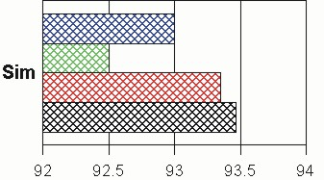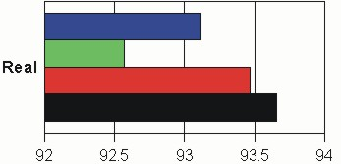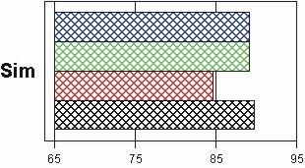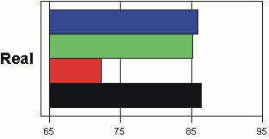
SH
NH

