Presnetation by Ron Errico on Radiation and Cloud subgroup meeting on 6/22/07

http://www.emc.ncep.noaa.gov/research/osse/NR/Jun07/RADIATION/Errico_cloudtalk_fnl_070622.x.ppt

Excerpt from presentation

Out line
- Lessons from previous OSSEs
- What are the important issues?
- Simulation of cloud cleared locations
- Simulation of errors remaining after QC

Decide what characteristics of observations and their errors
are critical to duplicate (and by how close an approximation)

The above decision depends on:

- How well the OSSE validation test criteria are to be satisfied
- How much development time is to be invested

My suggestion:

Let’s not aim for perfection for the new control simulations
(i.e., the ones using current operational observation data types),
but let’s strive to do significantly better than for previous OSSEs

Decide what characteristics of observations and their errors
are critical to duplicate (and by how close an approximation)

Validation of simulated locations

Ideally, the simulation of locations is validated, if global maps of simulated observation locations for individual observing periods are indistinguishable from random maps of real observation locations for equivalent periods.

Cloud Related Nature Run Fields
2-D:
Low cloud fractional coverage
Medium cloud fractional coverage
High cloud fractional coverage
Total cloud cover
Convective precipitation
Stratiform precipitation

3-D
Cloud liquid water content
Cloud ice water content
Cloud Cover

Our modest goal need not be to simulate the radiances from cloudy regions, but more simply to get the geographical distribution and selected innovation statistics “realistic.”

This is simpler because most details regarding the clouds are irrelevant.

Algorithm for determining cloud-cleared observation locations

For each grid box where a satellite observation is given, use the cloud fraction to specify probability that it is a clear spot. Then use random number to specify whether pixel is clear. Use a functional relationship between probability and cloud fraction that we can tune to get a reasonable distribution.

Sample functions for probability P=P(cloud fraction)

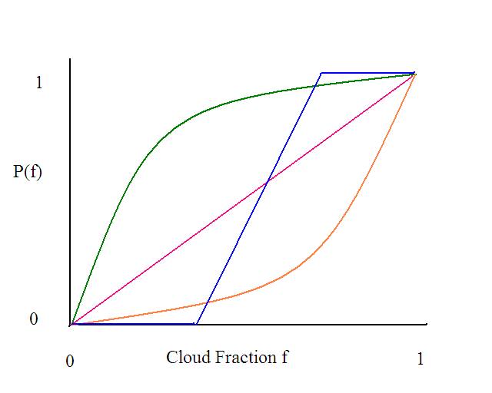
Strawman procedure for simulating observations

1. For each observation location ……
2. Bilinearly interpolate cloud fractions from NR grid to location
3. Compute P (f, tuning parameter)
4. Select random number x from uniform distribution (0,1)
5. If x>P then consider cloud free for this height of cloud, otherwise cloud covered point
6. If cloud free, then bilinearly interpolate q,T to location and compute radiances for these unaffected channels
7. If cloudy region, set radiance to very small value such that QC will detect and discard.
8. Repeat this process with various tuning parameters for P until the observation count and distribution look reasonable. Then use this parameter for all further experiments.

Information required from nature run:

T, q, Ps, Ts
Surface information that affects emmisivity

Instrument Plus Representativeness Error

- Since we have no real instrument, its errors must be entirely simulated.

- If different radiative transfer models (more generally called “forward
models” or “observation operators”) are used for simulation and
assimilation, then a portion of representativness error has already been added.

- The assimilation uses an interpolation algorithm (another form of forward
model) for interpolating from fields defined at analysis grid points to values
specified at observation locations. Similar models are also applied to the nature
run for simulated observation locations. Since the assimilation and N.R. grids
differ in resolution, there is another source for differing relationships between
grid point values. For these reasons, another portion of representativness error
has already been added when the simulated observations were created.

Instrument Plus Representativeness Error
- Obtain an estimate of the statistics of representativeness error
due to using 2 different RT models (biases and variances)
- Obtain an estimate of the statistics of representativeness error
due to differing grid resolutions and bilinear interpolation
- Generate errors to be added to each observation by drawing
random numbers from a N(R’,0) distribution. Ignore biases
since any large bias will be removed by the assimilation anyway.
Use R’<R, R being the error value specified in the DAS.
- Run the assimilation for a short time and note the variance of
the innovations. Re-adjust R’ so that this variance better matches
the corresponding variance computed for the real assimilation.
- After 1 or 2 iterations of this, use the final R’ in any further experiments.

Note: 1 and 2 are not strictly necessary for this purpose since they only
help in defining an initial iterate for R’. For interpreting results, however,
they should be very helpful. Otherwise a starting value for R’ can be, e.g.,
R’=2R/3.

